

|  |  |  |  |  |  |  |  |  |
| --- | --- | --- | --- | --- | --- | --- | --- | --- |
|  | | | | | | | | |
|  | | Business Requirements Document (BRD) | | | | |  | |
|  |  | | | | | | |  |
|  | | | |  |  | | | |
|  | | | | Megha Dwarakanath |  | | | |
|  | | | | October 28th 2024—Employee Onboarding System—Version 1.0 |  | | | |
|  | | |  | | |  | | |

# Project Overview

The Employee Onboarding system is designed to streamline and automate the process of integrating (onboarding) new employees into the company. The system is designed to cover core steps like Background checks, Documentation, and training schedules. The Employee Onboarding System aims to reduce the manual effort, increase accuracy, and improve the overall experience for both the HR staff and the new hires.

# Project Purpose and Background

##### Why is this project being undertaken?

This project addresses the inefficiency in the current manual onboarding process. The existing system is prone to manual errors, delay in onboarding and overall poor experience to both HR staff and the new hires, which may negatively impact the satisfaction of new employees.

#### What problem is being solved?

Currently, HRs have to manage multiple tasks manually, like verifying the documents, sending it for signature, scheduling the training and keeping track of the progress. The proposed system will:

* Automate repetitive tasks, reducing HR workload.
* Provide real-time tracking of the onboarding progress.
* Ensure that all compliance and documentation are completed efficiently.
* Improve the onboarding experience for new employees, reducing time to productivity.

#### Key Stakeholders Involved

* **Human Resources (HR) Department**: Responsible for managing and overseeing the entire onboarding process.
* **New Employees**: The primary users of the system, who will complete the necessary steps for onboarding.
* **IT Department**: Responsible for system integration, maintenance, and ensuring technical stability.
* **Department Managers**: Oversee the onboarding progress and ensure new employees are ready for their roles.
* **Senior Management**: Provide approval for the project.
* **Background Check Provider**: External entity that performs employee background checks through integration with the system.

# Objectives

* 1. To automate the onboarding process, from recruitment acceptance to the first 30 days of the employee’s tenure.
  2. To ensure all onboarding tasks, such as background checks, signing documents, and scheduling training, are completed efficiently.
  3. To track and manage employee onboarding progress.
  4. To maintain a seamless communication channel between HR, management, and the new employee.

# Scope of Work

##### In-Scope:

* Automating background checks.
* Electronic submission and signing of onboarding documents.
* Scheduling of training sessions.
* Progress tracking and reporting of onboarding tasks.
* Integration with existing HR systems (e.g., BambooHR).

##### Out-of-Scope:

* Employee offboarding processes.
* Payroll integration (unless specified otherwise).

# Stakeholder Identification

##### Roles & Responsibilities:

* **HR Department:**
  + Manage the onboarding workflow and ensure all necessary steps (background checks, document signing, training) are completed.
  + Provide feedback to the IT department on system functionality.
  + Track the onboarding progress and intervene when necessary.
* **New Employees:**
  + Complete onboarding tasks, including background checks, filling out forms, and attending training.
  + Provide feedback on the ease of use and any difficulties encountered in the onboarding system.
* **IT Department:**
  + Oversee system deployment and integration with existing HR systems.
  + Ensure data security, manage user permissions, and maintain the system’s uptime.
  + Respond to and resolve any technical issues reported by HR or new employees.
* **Department Managers:**
  + Monitor new employees’ onboarding progress via the system’s reports.
  + Ensure that employees are prepared for their roles by confirming that they have completed the required training and documentation.
* **Senior Management**:
  + Approve the implementation of the onboarding system.
  + Review onboarding performance metrics, including time to completion and employee satisfaction, to ensure the project meets organizational goals.
* **External Background Check Provider**:
  + Perform background checks on new hires as part of the onboarding process.
  + Ensure timely and secure transfer of background check results to the HR system.

# Functional Requirements

* 1. The system shall allow HR staff to upload and manage onboarding documents.
  2. The system shall automatically initiate background checks after an offer acceptance.
  3. The system shall allow new employees to complete onboarding documentation online.
  4. The system shall send automated reminders for incomplete tasks.
  5. The system shall allow the scheduling of onboarding training, with the ability to reschedule.
  6. The system shall generate onboarding progress reports for HR and management.

# Non-Functional Requirements

* 1. The system shall be available 99.9% of the time.
  2. The system shall provide data encryption for secure document handling.
  3. The system shall be scalable to support onboarding across multiple locations.

# User Requirements

* **User Story 1**: As a HR Personnel, I need:
  + User-Friendly Interface –
    - The system must have an intuitive interface for HR personnel to manage and monitor the entire onboarding process, with minimal training required.
  + Document management –
    - Ability to upload, store, and manage employee documents, such as offer letters, contracts, and policies.
    - Automated reminders for document submission deadlines.
    - Tracking of document signing status and progress.
  + Background Check Automation –
    - Integration with third-party background check providers to automatically initiate checks upon employee offer acceptance.
    - Real-time status updates of background checks to monitor progress.
  + Task Management –
    - A task dashboard that allows HR to assign, track, and complete onboarding tasks such as document collection, form completion, and training scheduling.
    - Automated notifications for incomplete tasks or missed deadlines.
  + Training Schedule Management –
    - Ability to assign mandatory training sessions and monitor employee progress.
    - Option to reschedule or adjust training plans if needed.
  + Reporting & Analytics –
    - Access to onboarding reports, including task completion rates, training progress, and background check statuses.
    - Insights into the overall onboarding experience, including time taken to onboard employees.
  + Communication Tools –
    - Built-in communication features to notify employees of tasks, send reminders, and share relevant documents or updates during the onboarding process.
* **User Story 2**: As a New Employee, I want:
  + Self-Service Portal
    - A simple, user-friendly portal for new hires to log in and complete onboarding tasks at their own pace.
    - Easy access to all onboarding forms, documents, and policies they need to review and sign.
  + Background Check Submission
    - Ability to submit background check details directly through the system.
    - Real-time status updates on the progress of their background checks.
  + Document Signing & Submission
    - The system must allow employees to digitally sign documents and submit required personal information securely.
    - Automatic reminders for pending documents or forms.
  + Training Access
    - Access to mandatory training sessions, with details on completion deadlines.
    - Ability to complete training modules online, with tracking for HR to review progress.
  + Task Overview
    - A clear task list outlining all onboarding steps, deadlines, and requirements.
    - Notifications for upcoming deadlines or incomplete tasks.
  + Communication with HR
    - A built-in communication feature to ask HR questions or request support during the onboarding process.

# Process Flow

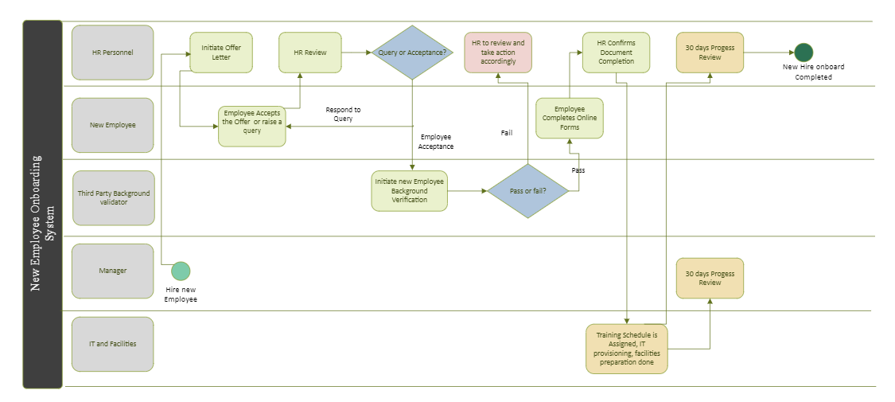

# Assumptions and Constraints

* All employees have access to the internet and a device to complete online forms.
* HR will oversee onboarding progress and intervene if necessary.

# Dependencies

* Integration with the current HR system (e.g., BambooHR).
* Cooperation with external background check providers.

# Acceptance Criteria

* List of conditions that must be satisfied for the solution to be accepted.
* Define how success will be measured.

# Risks

* Data security risk during document exchange.
* Delays in background checks could impact the onboarding schedule.

# Approval

* **Business Owner:** Megha Dwarakanath
* **Date:** 28th October 2024

|  |  |  |  |
| --- | --- | --- | --- |
|  | REPORT TITLE | PAGE 4 |  |